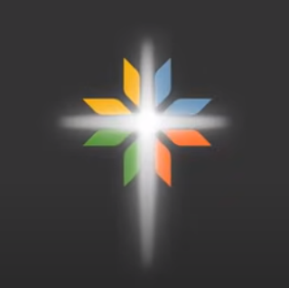
United Women in Faith
Memorials Report 2024

By the Unit Spiritual Growth Coordinator or
Local Unit President

Report unit deaths occurring June 1, 2023 to May 31, 2024
and not acknowledged at the prior year’s Annual Celebration.
If your unit has no deaths, please send a report indicating such.

Send local reports to your District Spiritual Growth Coordinator or
District President by June 1, 2024.

District:____________________________________, Northwest Texas Conference
Local Unit & Church Name:_____________________________________________
Unit President: ______________________________________________________
Address: ______________________________Phone:_______________________
City: _______________________Zip___________E-Mail_____________________
Person Reporting: _________________________________Phone:_____________

Memorial Names (PRINT) with Phonetic Spelling
1. ________________________________________________________________
2. ________________________________________________________________
3. ________________________________________________________________
4. ________________________________________________________________
5. ________________________________________________________________
6. ________________________________________________________________ Add a page/lines to list as many names as necessary.
The district coordinator or president will compile all reports and send a typed District Report to Brenda Breeden, 1164 Yorktown Dr, Abilene, TX 79603 or snoopyb1@suddenlink.net, by July 1, 2024.

All memorial names are printed in the Annual Celebration program book, and all names are read aloud during the Memorial Service held during Annual Celebration.

Last Updated 10/2023

