UNITED WOMEN IN FAITH SUNDAY 2024

Theme: Working Together, Pressing On

Philippians 3:12
¹² Not that I have already attained,^{[a]} or am already perfected; but I press on, that I may lay hold of that for which Christ Jesus has also laid hold of me. NKJV

James 2:22
²² You see that his faith and his actions were working together, and his faith was made complete by what he did. NIV

Each local unit should hold this annual special Sunday on which United Women in Faith celebrate 155 years of service to women, children, and youth around the world.

Select a date by May 31, 2024 that works for your church. Plan the observance with your pastor and involve your pastor(s) in the service.

Soon after your observance, send the report form. Include a copy of the worship bulletin and materials distributed.

OBSERVANCE SUGGESTIONS
UNITED WOMEN IN FAITH SUNDAY 2024

- Be sure your speaker has needed advance information – theme, theme scripture, copy of previous year’s bulletin, bulletin insert recapping mission work during the year, sources of information about United Women in Faith.

- Choose hymns and other music of choice to carry out the theme.

- Let the congregation know about your mission involvement during the past year’s time. UWFaith Sunday is a public relations opportunity. Develop a bulletin insert recapping your activities since your previous observance. After the event, distribute extra copies to members not in attendance.

- Present your annual Special Mission Recognition(s). Order this from your district treasurer well in advance. Consider framing the certificate before presentation.

- Have someone develop and present the children’s sermon. Sermons4kids.com has a very good sermon for Philippians 3:12 titled The Next Chapter.

- Present mission ribbons during the children’s sermon. You might attach with a safety pin a note to each ribbon stating “This mission ribbon represents a money gift that United Women in Faith sent to Mission Giving so children around the world might hear about Jesus. The money also helps children to have food, get health care, and go to school.”

- Find creative ways to present ribbons to adults. You might use them to identify members of United Women in Faith. Contact your district president for ribbon sources. This is an inexpensive way to increase your Mission Giving.

- Consider taking a special offering for Mission Giving for United Women in Faith.

- Involve as many United Women in Faith in the service as possible – ushers, greeters, liturgists, other speaking parts. Instruct about effective microphone use. Non-members are involved as needed.

- Develop your own bulletin cover and order of worship. Include the logo, theme, theme scripture, original art and/or clip art. Copy and paste the logo from the top of the first page; enlarge to desired size.

- Ask present and past members to stand.

- Ask men and women to stand who through the years have received a Special Mission Recognition. Encourage past recipients to wear their SMR pin(s) to the service.

- Honor home bound members by calling their names.

- Have a Memorial Moment with the reading of names of United Women in Faith members who died since your previous UWF Sunday observance. Consider using a bell tone as each name is called.

- Consider taking your guest speaker as well as your clergy staff and families to lunch. Invite others to join you. Or consider having a pot luck meal at church.

- Find and use other relevant scripture, quotes, music, art, and children’s sermon.

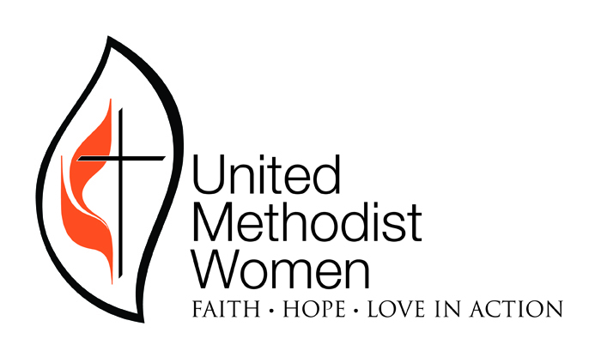
UNITED WOMEN IN FAITH SUNDAY 2024 LOCAL UNIT REPORT

Working Together, Pressing On

Submit this report immediately after your local observance. Send this page, a copy of your worship bulletin, and any other included United Women in Faith materials to
Carolyn Cobb, 1591 FM 2301, Tulia TX 79088-6400 or email to cobbcgj0@gmail.com.
Contact Carolyn for questions by email or 806 627 8118. You may save this document as a Word document, type on it, then save and send by email.

Units reporting your participation in this special day will be acknowledged during the Northwest Texas Conference Annual Celebration for United Women in Faith.

Suggestions for observance are widely distributed by email. They may also be found on nwtxconf.org under Ministries>United Women in Faith.

Unit (city and exact name of church) ________________________________________

Name and contact information of person reporting_____________________________

Date of observance________________________________________________________

Name of speaker__________________________________________________________

What special things did you do while observing United Methodist Women Sunday?
What local church obstacles and restrictions did you overcome?

