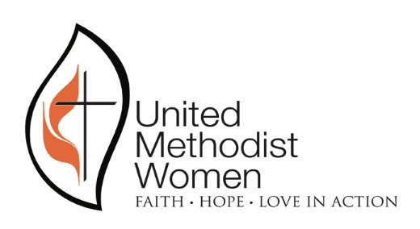
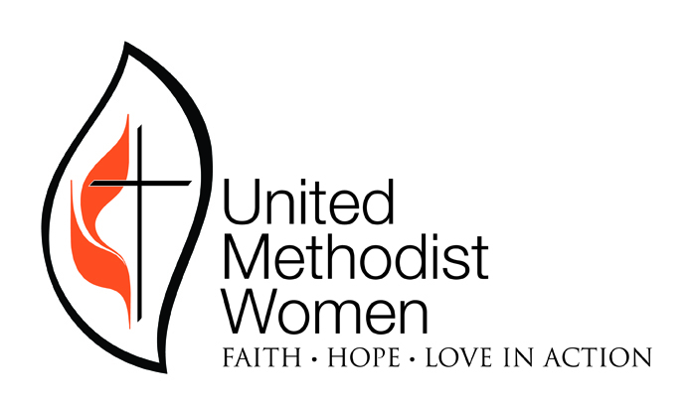

MISSION TODAY REPORT 2019
NORTHWEST TEXAS CONFERENCE UNITED METHODIST WOMEN

Local unit name: _________________________Circle District: Abilene, Amarillo, Big Spring, Lubbock

Name of person reporting and contact information: ___________________________________________

_______________________________________________________________________________________

PURPOSE: United Methodist Women shall be a community of women whose purpose is to
know God and to experience freedom as whole persons through Jesus Christ; to develop a creative, supportive fellowship; and to expand concepts of mission through participation in the global ministries of the church.

Mission Today is what keeps us United Methodist Women.

Each local group (unit) will meet the following four basic expectations to become a basic Mission Today group. Circle Yes or No to indicate whether your local unit complied with each expectation.

Yes No 1. Each member understands and affirms the Purpose.

Yes No 2. Make and pay a Pledge to Mission for the group. This is sent to your District Treasurer who records and sends to the Conference Treasurer.

Yes No 3. Send a local unit membership report in January to the name/address on the form.

Yes No 4. Send this local group Mission Today report by June 30, 2016 to the Conference President Pam Zwickey 19651 SW 34th Ave. Amarillo, TX 79119 or email to pdztx@yahoo.com.

In addition to the four basic expectations, each local group is encouraged to participate in as many of the following items as possible so that we may become more united in
Living Our Vision and Making It Happen.

Circle Yes or No to indicate whether your local unit completed each expectation and provide documentation.

Yes No 1. Celebrate United Methodist Women Sunday in your local church. Send the report to the name and address on the report form.

Yes No 2. Participate in FIVE STAR channels of giving. The local treasurer sends all funds through the district treasurer who records and sends to the conference treasurer. The group or an individual member gives each of the following: Gift in Memory, Gift to Mission, Special Mission Recognition, and World Thank Offering. (The 5th Channel is the Pledge to Mission which is a basic expectation.)

Yes No 3. Contribute to a specific mission project of National United Methodist Women. Monetary
contributions are sent by the local treasurer to the district treasurer. Supplies for a hands-on project such as UMCOR (United Methodist Committee on Relief) are sent through the Northwest Texas Conference office or other designated UMCOR collection sites. Supplies for a National Mission Institution such as Amarillo Wesley Community Center are given directly to the mission or a designated collection site. A list of institutions supported by United Methodist Women is available. List your mission project(s).

Yes No 4. At least one member completes a plan of the Reading Program, choosing from Plans 1-4. Send individual report forms to the conference president.

Yes No 5. The group stays informed and/or participates in legislative matters. Explain:

__________________________________________________________________________________________

Yes No 6. Communicate with five persons in mission. (in person, postal mail, email,) List names of those persons in mission:

Yes No 7. Add at least one new member. List name(s):______________________________________

Yes No 8. Implement the Charter for Racial Justice. (local activities carried out without regard to race, ethnicity, or any other similar criteria) Explain:

_______________________________________________________________________________________

Numbers 9-14 involve using United Methodist Women resource material.

Yes No 9. Use the Prayer Calendar throughout the year. How did you use the Prayer Calendar?

Yes No 10. Use the Program Book as a program resource at one or more gatherings. How did you use?

__________________________________________________________________________________________

Yes No 11. Use one or more Reading Program books as a resource for programs at gatherings. Explain.

__________________________________________________________________________________________

Yes No 12. Use response magazine and/or New World Outlook as a resource for programs at gatherings. How did you use these?

__________________________________________________________________________________________

Yes No 13. Have at least one Study from the study books produced by National United Methodist Women. Send the Study report to the name/address on the report form.

Yes No 14. Use www.unitedmethodistwomen.org as a source for programs. Share how you used this site.

__________________________________________________________________________________________

Numbers 15-22 promote learning and unity by attending United Methodist Women events.

Yes No 15. Attend a District-wide event of United Methodist Women. List event(s) and attendee(s).

__________________________________________________________________________________________

Yes No 16. Attend NWTX Conference Leadership Development Day. List participant(s).

__________________________________________________________________________________________

Yes No 17. Attend Spiritual Growth Retreat. List attendee(s). _________________________________

_______________________________________________________________________________________

Yes No 18. Attend United Methodist Women and Friends Dinner at Annual Conference. List attendee(s).

Yes No 19. Attend Mission u. (List participant(s). __________________________________________

_______________________________________________________________________________________

Yes No 20. Attend Annual Celebration of the NWTX Conference. (List attendee(s).

__________________________________________________________________________________________

Please feel free to tell us your exciting news about your unit that is not included on this form.

